🔹 Abstract for Static Resume Website
A static resume website is a personal online profile built using fundamental web technologies such as HTML and CSS. It serves as a digital version of a traditional resume, presenting an individual’s skills, education, experience, and projects in a structured and visually accessible format. Unlike dynamic web applications, it does not require a backend or database, making it lightweight, fast-loading, and easy to deploy on platforms like GitHub Pages or Netlify. This type of website enhances personal branding by allowing recruiters and visitors to quickly view and evaluate professional information from any device with internet access.

🔹 Introduction for Static Resume Website
A static resume website is a simple and effective way to present personal and professional information online. It is built using basic web technologies such as HTML and CSS without the need for a backend or database. The main purpose of this website is to create a digital version of a traditional resume that can be easily accessed through the internet.
This website typically includes sections such as personal details, skills, education, projects, and contact information. Since it is static, it loads quickly, is easy to maintain, and can be hosted freely on platforms like GitHub Pages or Netlify.
A static resume website helps individuals showcase their profile in a more attractive and interactive way compared to a traditional paper resume, making it useful for students, job seekers, and professionals.

🔹 Objectives of a Static Resume Website
The main objective of a static resume website is to create a simple, accessible, and professional online representation of an individual’s profile. It aims to present personal, educational, and professional details in a clear and organized manner using basic web technologies like HTML and CSS.
Another key objective is to make the resume easily accessible to recruiters and employers anytime through the internet. It also helps in improving personal branding by showcasing skills, projects, and achievements in a visually appealing format.
Additionally, a static resume website is designed to be lightweight, fast-loading, and easy to deploy on free hosting platforms such as GitHub Pages or Netlify, making it a practical solution for students and job seekers.

🔹 Requirements for a Static Resume Website
To build a static resume website, a few basic tools and technologies are required. These include:
- HTML (HyperText Markup Language): Used to structure the content of the website such as headings, paragraphs, lists, and sections.
- CSS (Cascading Style Sheets): Used to design and style the website, including layout, colors, fonts, and responsiveness.
- Text Editor: Any code editor like Visual Studio Code, Sublime Text, or Notepad++ to write and edit the code.
- Web Browser: Google Chrome, Firefox, or any browser to view and test the website.
- Images/Assets (optional): Profile photo or icons to enhance the visual appearance of the resume.
- Hosting Platform (optional): GitHub Pages or Netlify to publish the website online and make it accessible publicly.
These requirements are minimal, making a static resume website easy to develop, maintain, and deploy.

🔹 Algorithm for Creating a Static Resume Website
- Start
- Collect Information
  - Gather personal details (name, contact, email)
  - Collect educational background
  - List skills and technologies
  - Prepare project details and achievements
- Create Project Folder
  - Make a folder for the website
  - Create files: index.html, style.css
- Design HTML Structure
  - Open index.html
  - Add basic HTML structure (head, body)
  - Create sections like:
    - Header (Name and title)
    - About Me
    - Skills
    - Education
    - Projects
    - Contact
- Add Content
  - Insert collected information into each section
  - Format using headings, paragraphs, and lists
- Apply Styling
  - Open style.css
  - Add styles for layout, colors, fonts, and spacing
  - Make the website visually appealing and readable
- Test Website
  - Open index.html in a web browser
  - Check layout, alignment, and responsiveness
- Fix Errors (if any)
  - Correct HTML or CSS mistakes
  - Improve design if needed
- Deploy Website
  - Upload files to GitHub Pages or Netlify
  - Get live website link
- End
Flowchart-
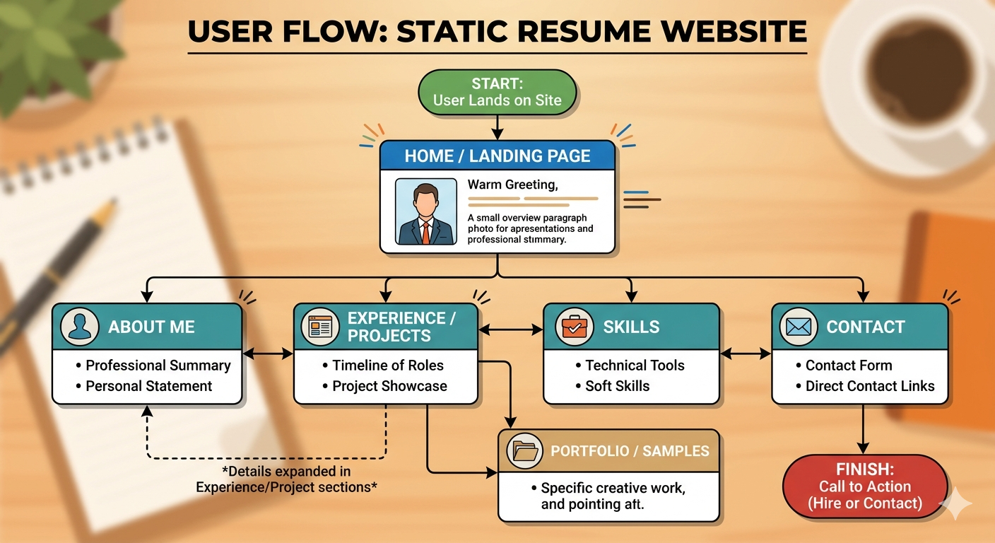

🔹 Methodology of a Static Resume Website
The methodology for developing a static resume website describes the step-by-step approach used to design, build, and deploy the project using basic web technologies.
- Requirement Analysis
Identify the purpose of the website and collect all necessary information such as personal details, education, skills, and project experience.
- Design Phase
Plan the structure of the resume website by dividing it into sections like About Me, Skills, Education, Projects, and Contact. Decide the layout and visual appearance.
- Development Phase
  - Create the main structure using HTML
  - Add content to each section
  - Style the webpage using CSS to improve appearance and layout
- Testing Phase
Open the website in different browsers to check layout, responsiveness, and correctness of content. Fix any errors in code or design.
- Deployment Phase
Upload the project files to hosting platforms such as GitHub Pages or Netlify to make the resume accessible online.
- Maintenance Phase
Update the website whenever there are changes in skills, projects, or achievements to keep it current and relevant.

🔹 Results of the Static Resume Website
The development of the static resume website successfully produced a simple, responsive, and user-friendly online resume. The website displays personal information, educational background, technical skills, projects, and contact details in a well-organized format.
The final output is a lightweight webpage built using HTML and CSS that loads quickly across different browsers and devices. It provides an easy way for recruiters and viewers to access professional information anytime through a single link.
The website also improves personal visibility and digital presence, serving as an effective alternative to traditional paper resumes. Additionally, it can be easily hosted on platforms like itHub Pages or Netlify and updated whenever required.

